Lesson 5 Demo 15: Select Storage Driver and Configure Device Mapper

This section will guide you to:

* Select a suitable storage driver
* Configure the device mapper storage driver

**Step 1:** Select a suitable storage driver

* Open the *daemon.json* file to change the default storage driver to *aufs*

*sudo nano /etc/docker/daemon.json*



* Use the following code to change the default storage driver:

**Note:** Please type the code snippet shown in the screenshot below in your terminal to avoid any errors rather than copy pasting the code.

"*storage-driver*": "*aufs*"

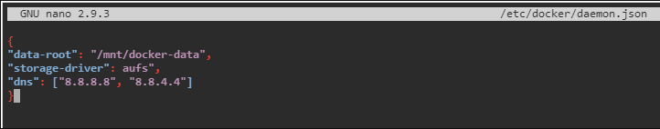

**Note**: Press **Ctrl+X** to exit the editor. Then type **Y** and press **Enter** to save the file.

* Use the following command to restart the Docker Daemon:

*sudo service docker restart*

**

* Use the following command to check the default storage driver:

*sudo docker info | grep 'Storage Driver'*

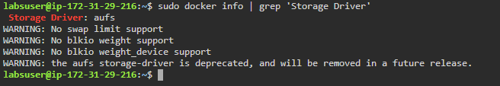

**Note:** You can select any storage driver that is suitable to your Docker engine version and requirements, from storage drivers like *overlay, overlay2, device mapper,* and *aufs.*

**Step 2:** Configure the *device mapper* storage driver

* Open the *daemon.json* file to change the default storage driver to *device mapper*

*sudo nano /etc/docker/daemon.json*



* Use the following code to change the current storage driver:

"*storage-driver*": "*devicemapper* "

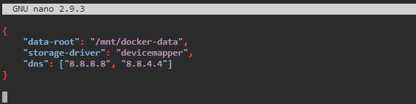

**Note**: Press **Ctrl+X** to exit the editor. Then type **Y** and press **Enter** to save the file.

* Use the following command to restart the Docker Daemon:

*sudo service docker restart*

**

* Use the following command to check the default storage driver:

*sudo docker info | grep 'Storage Driver'*

